LAB EXPERIMENTS

Experiment 1:

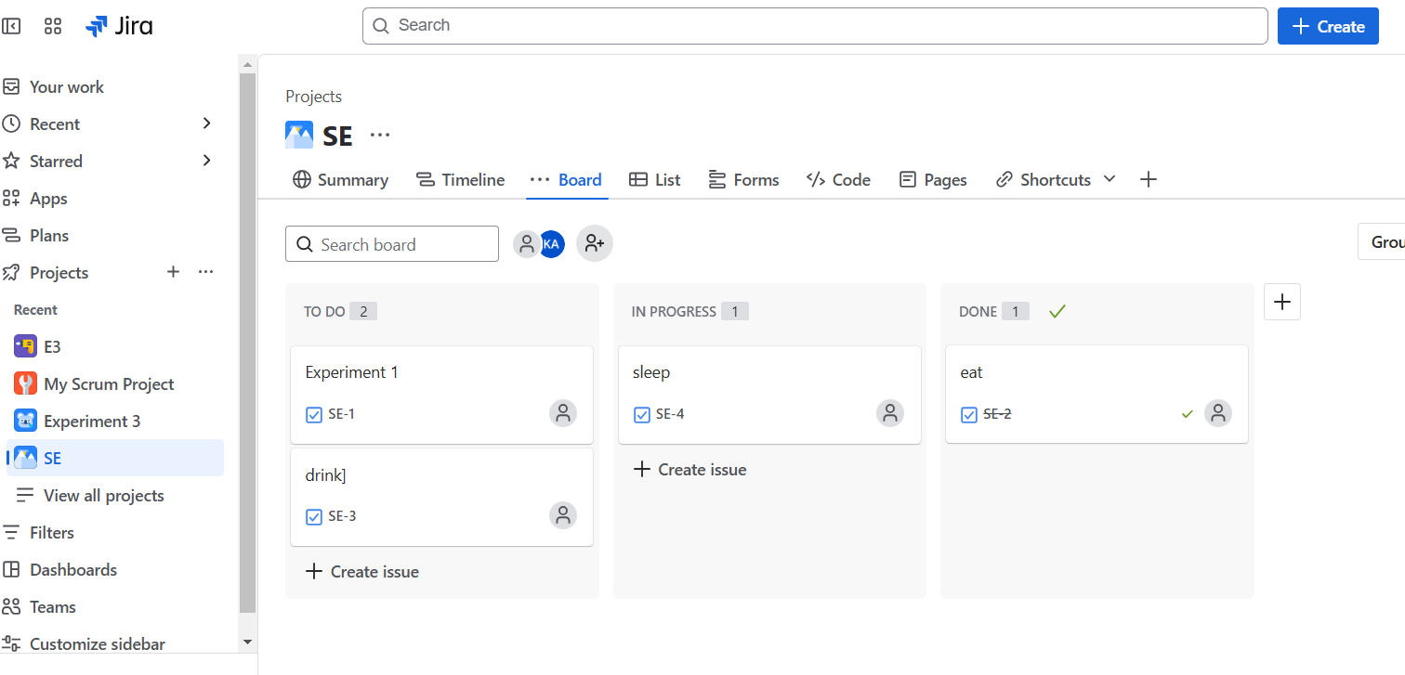

Experiment 2:

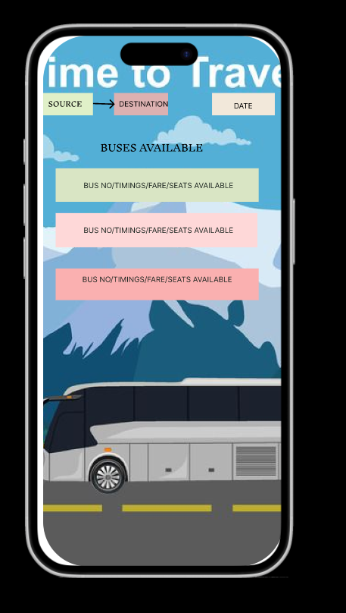

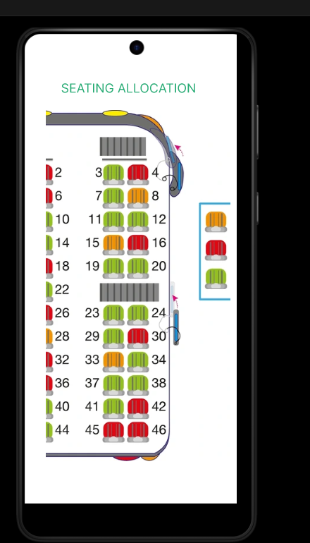

Experiment 3:

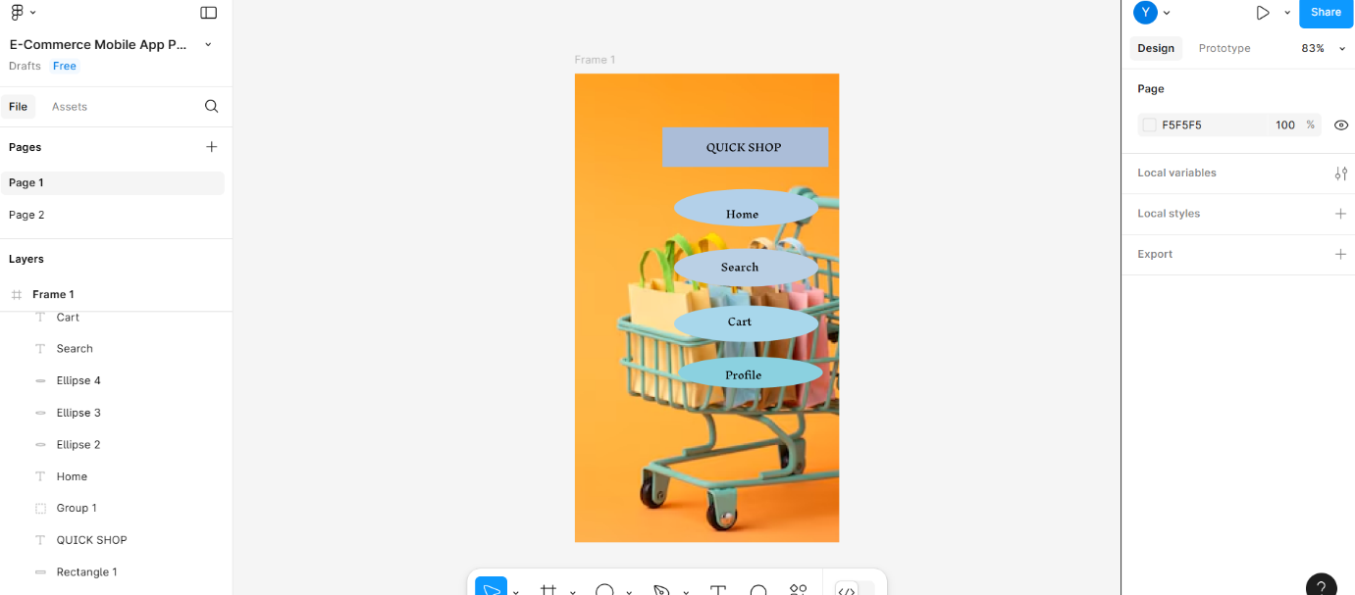

Experiment 4:

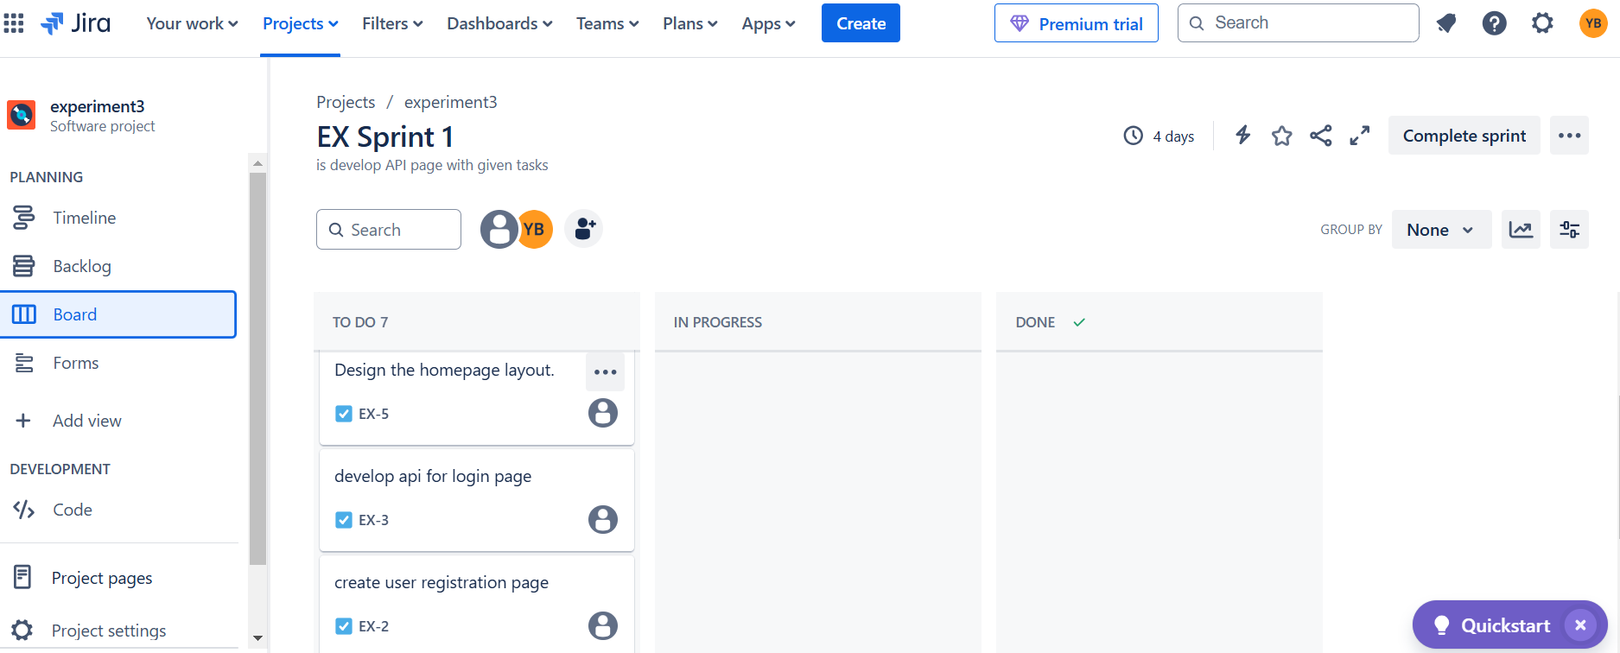

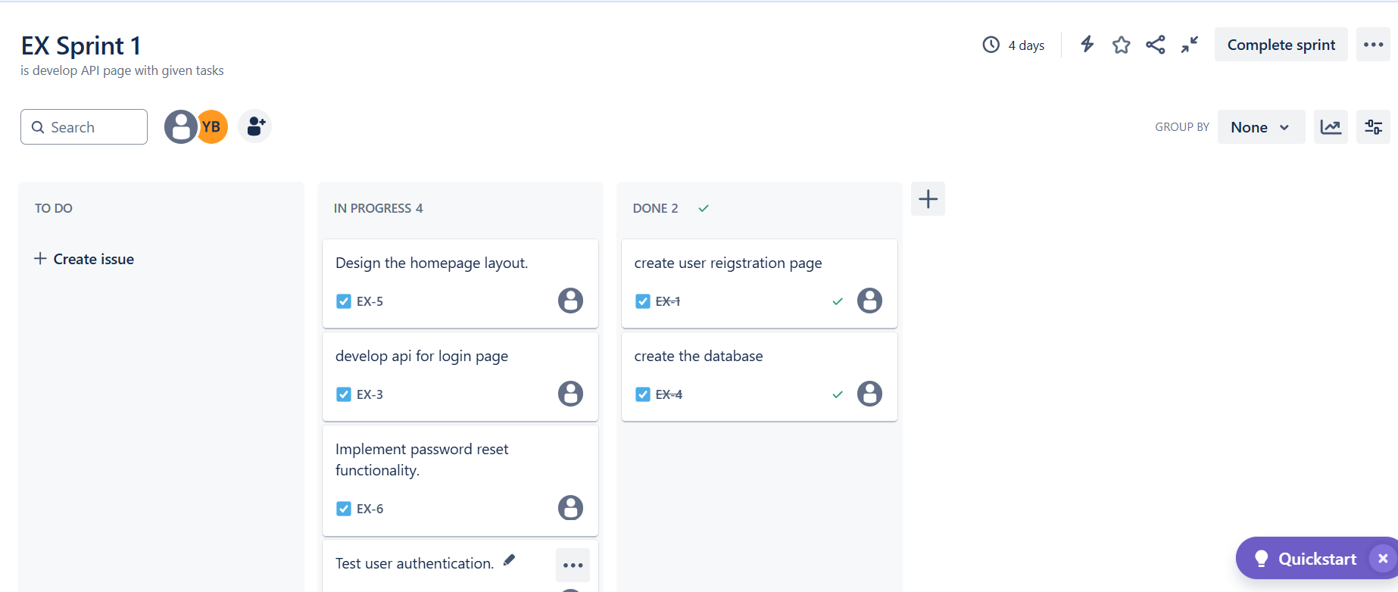

Experiment 5:

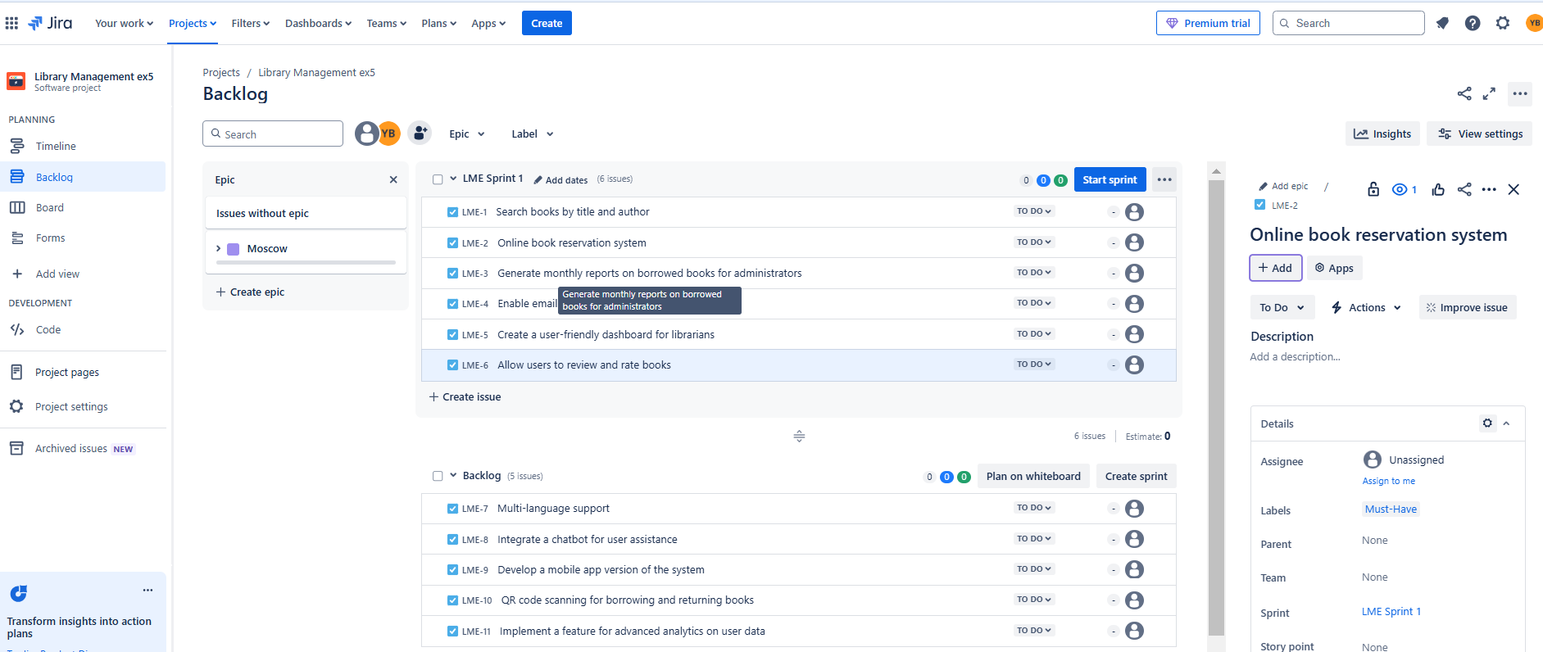

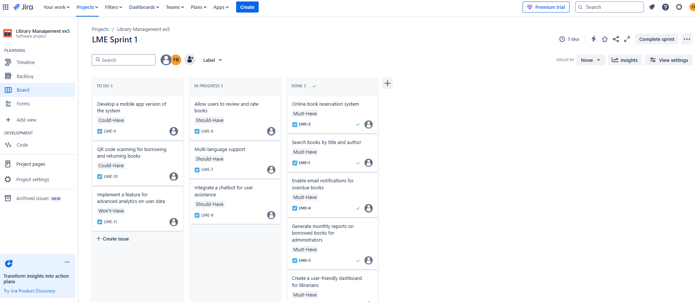

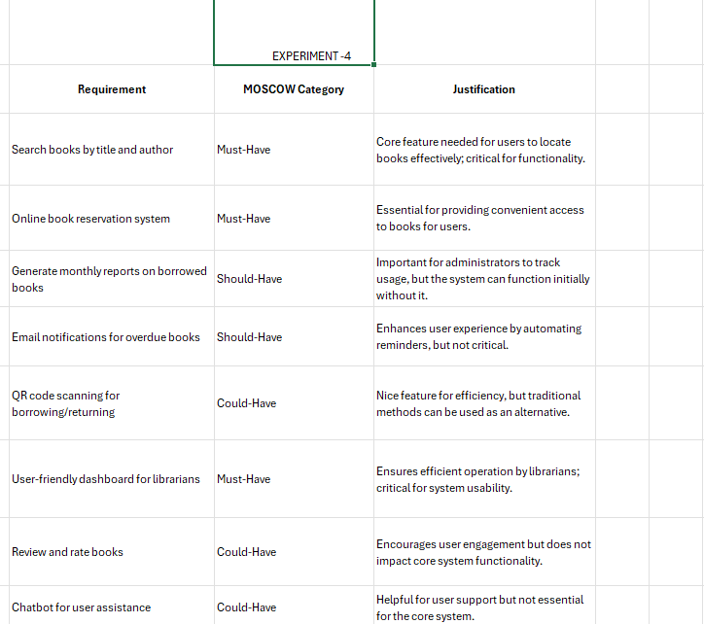

Experiment 6:

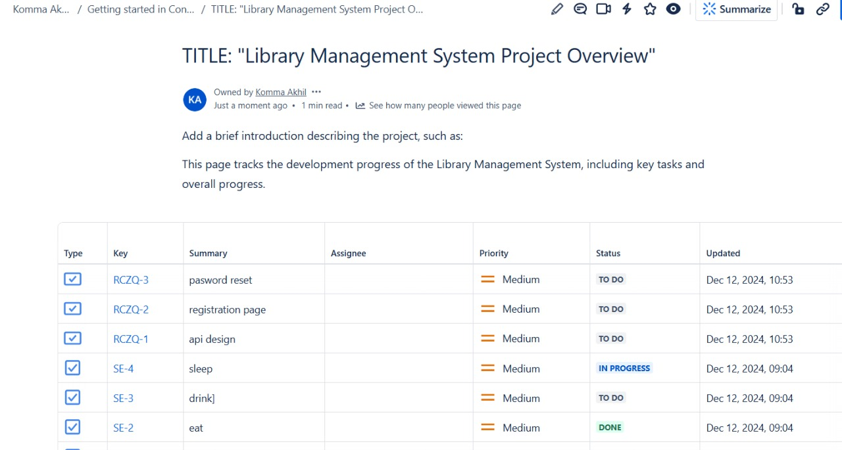

Experiment 7:

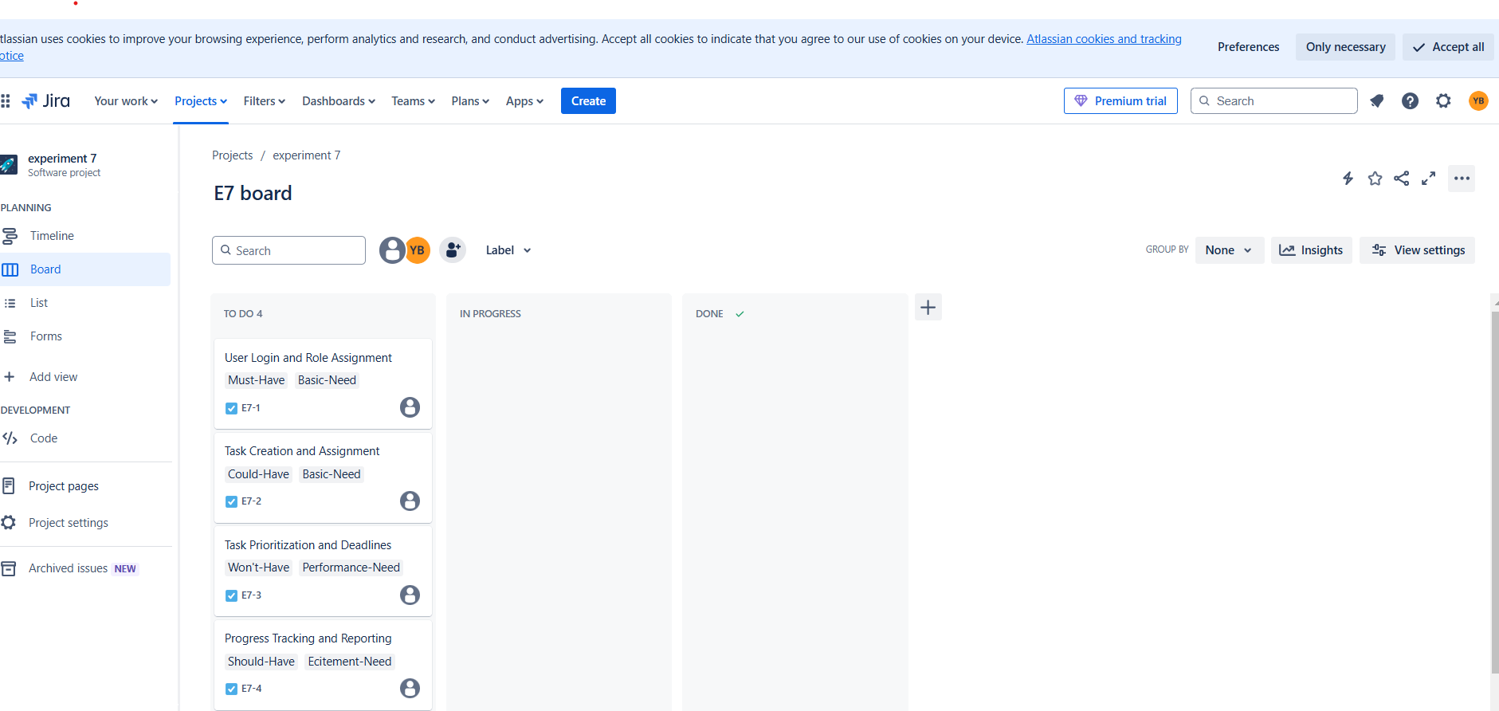

Experiment 8:

Experiment 11:

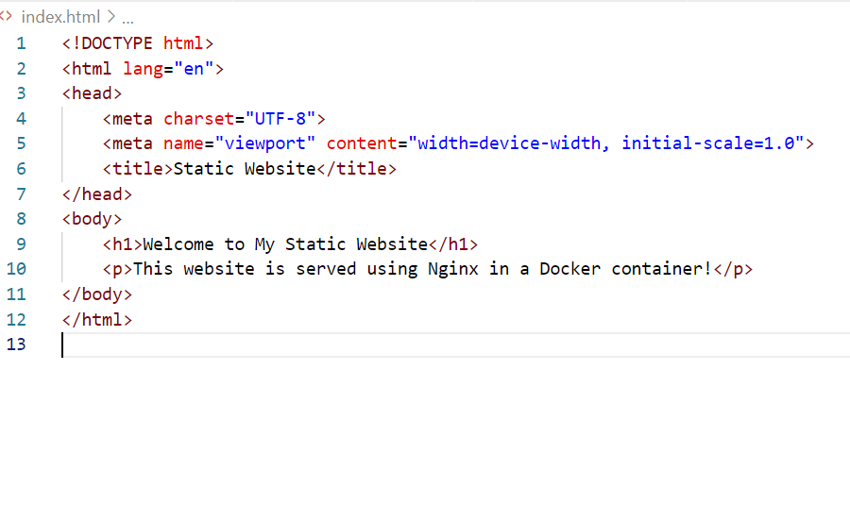

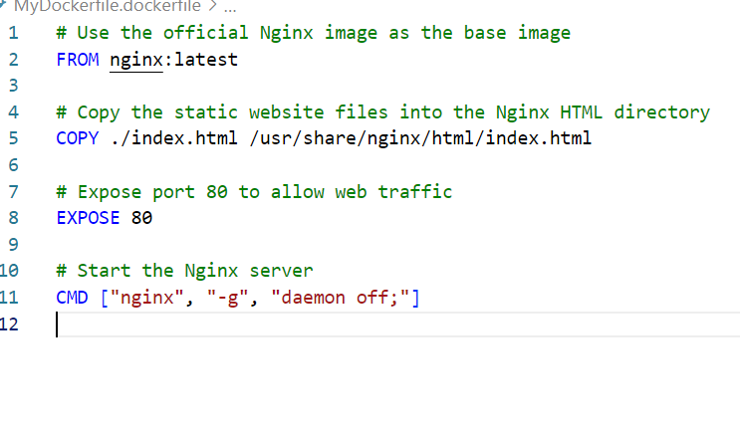

Experiment 14:

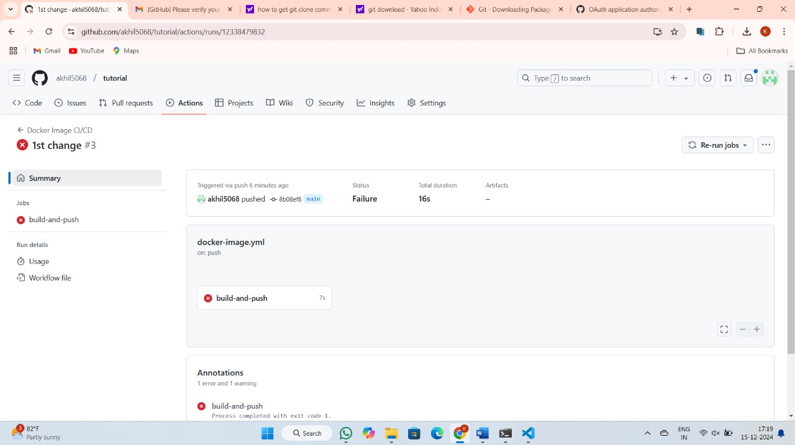

Experiment 17:

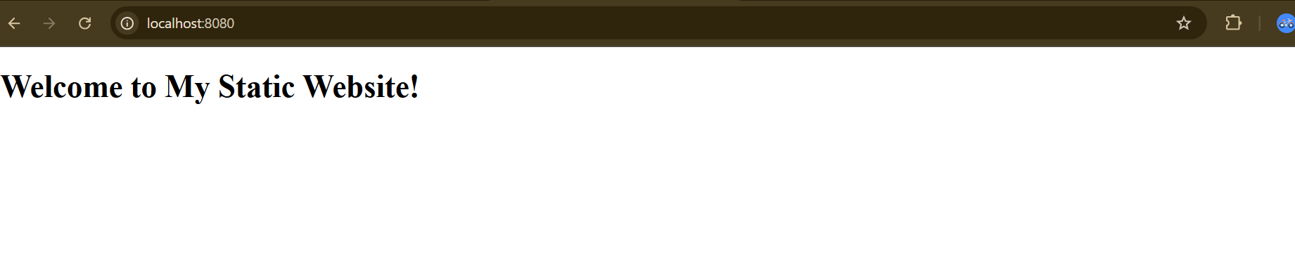

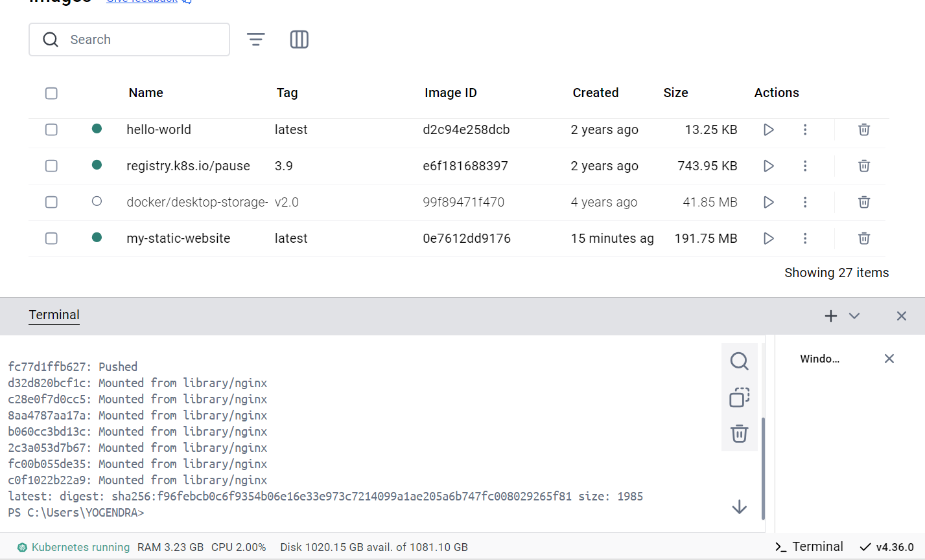

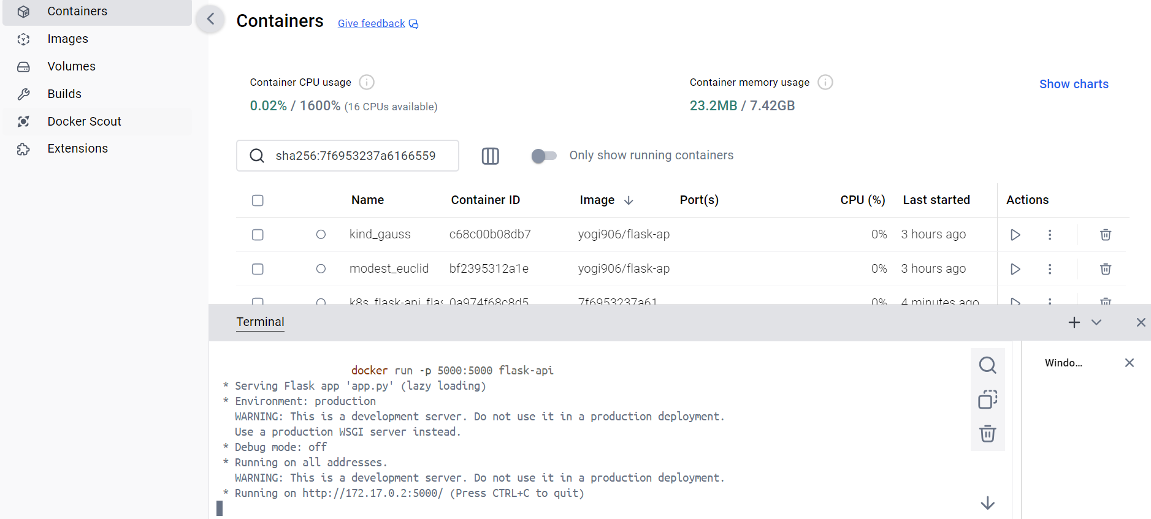

Experiment 20:

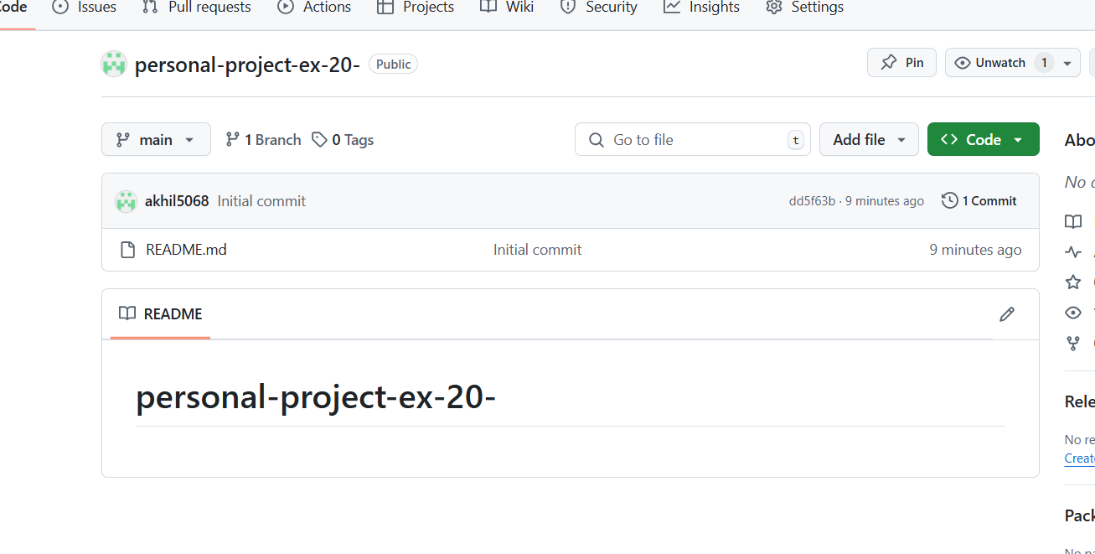

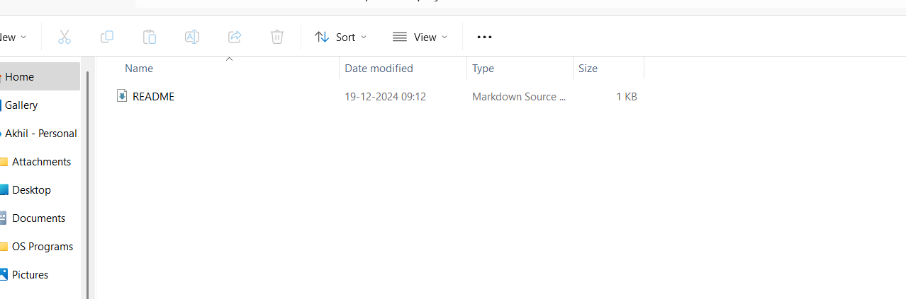

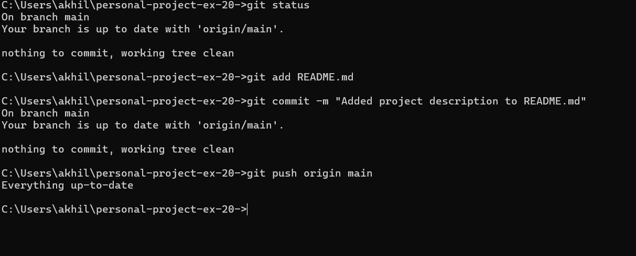

Experiment 23:

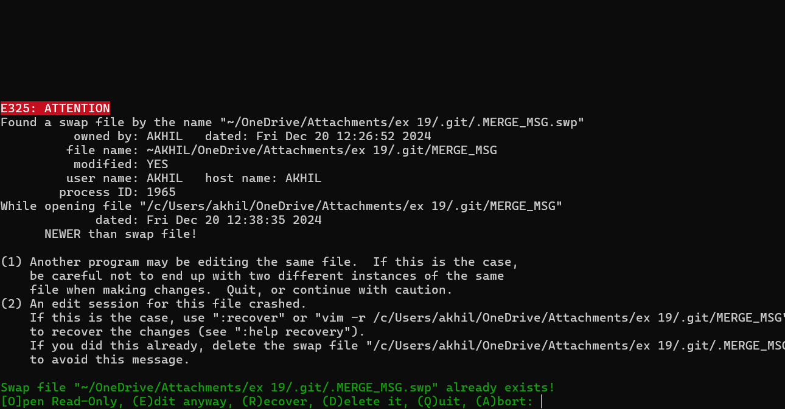

Experiment 24:



